Looping playback problem in Flash and AC3.
Those who have ever tried to introduce (embedded?) a sound into a swf-file, the one most likely faced the problem of looping playback. In AC3 is not the richest opportunities to work with sound, but the some highlights are available.
So, what do we have? According to a certificate from Adobe (http://help.adobe.com/en_US/AS3LCR/Flash_10.0/index.html) flash player supports stereo mp3, which can played with help objects, such as Sound and SoundChannel. Take the guinea pig sinusoidal signal length of about half a second and try to force him to play in cycles.
Our test signal looks like this:
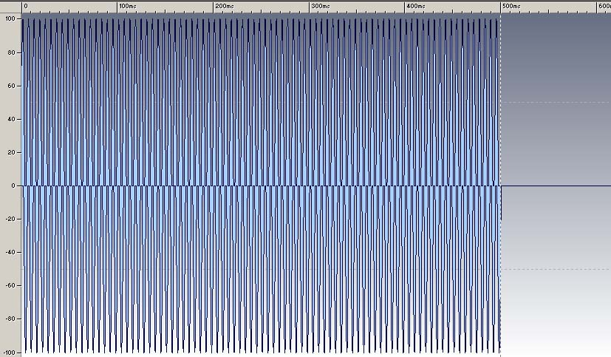

Making sure that the cyclical reproduction of the tracks we have no audible "click", when switching from end to beginning. This can be evaluated simply listening to audio loop in the program sound processing, or visually increase the scale of mapping sound waves and connecting the end of the beginning. About something like this:
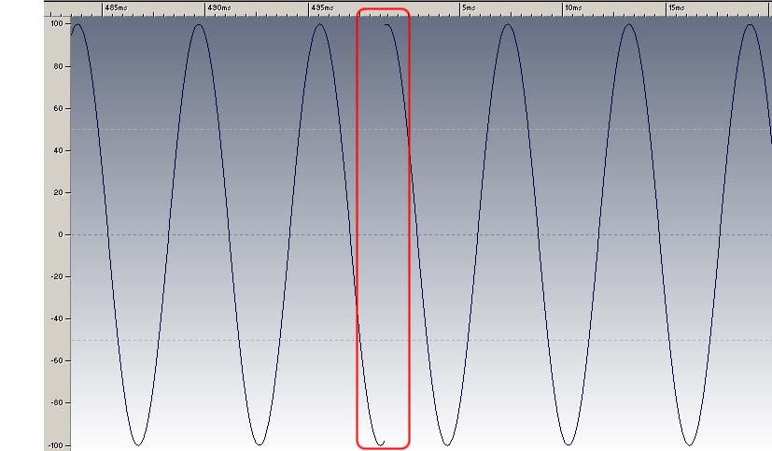

In our sample there is difference in sound level at the transition from the end of the beginning. The result is "clicking" from listening audio loop. Let's remove it for the purity of the experiment. 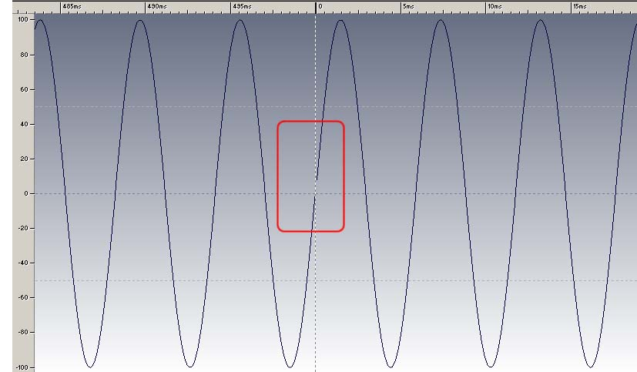

Now, when listening to the "click"-effect does not occur. The resulting sample encoding in mp3's with standard settings (Mono / LameEnc 48kbps/44100 Hz).
So started. Now create a small project, which will check and cycle of the sound. The code will look to start like this:
package
{
import flash.display.Sprite;
import flash.events.Event;
import flash.media.Sound;

/**
* @author Ezhi, mail:ezhi@story-game-play.com
*/
public class Main extends Sprite
{
[Embed(source="//..//assets//sample_no_click.mp3")]
private var sampleSrc:Class
private var sampleSound:Sound;

public function Main():void
{
if (stage) init();
else addEventListener(Event.ADDED_TO_STAGE, init);
}

private function init(e:Event = null):void
{
removeEventListener(Event.ADDED_TO_STAGE, init);

sampleSound = new sampleSrc() as Sound;
sampleSound.play(0, 10);
}
}

}

It seems to be all right, when you play indicated that our sample should be repeated 10 times. As a result it was expected to hear the hum of 500ms * 10 = 5 seconds. But, unfortunately, not quite hear. Instead of a smooth hum, hum happened with clearly visible pauses. Question: where have the pauses, which we did not do? The answer to this question lies in the mp3 format specification (http://lame.sourceforge.net/tech-FAQ.txt например здесь об этом можно узнать, возможно эта ссылка не нужна), which adds a delay in the beginning and end of the resulting file. This is very good to be seen if we take the original wave file (blue) and compare it with the mp3 file (yellow).
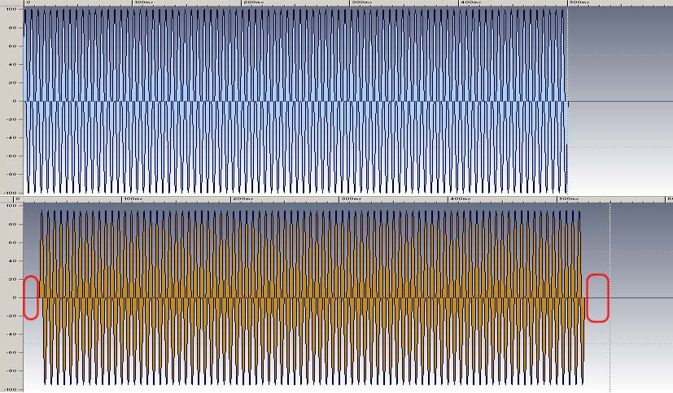

We have added a delay in the beginning and end of the file. Also changed the overall length of the sample on the value of delay. Sad news, it is especially sad that these delay can not get rid of all, they imply a standard mp3 file. The standard says that in the end and beginning of the file is added delay the size of 528 samples. But the main problem lies in the fact that at the beginning of the file, while his sound structure is not known, 528 samples accurately placed in 25 milliseconds, but at the end of the file size of the sample is another, besides badly predicted. Verify this assertion bold experiment. Take a few types of sound signals and encode them. Red is marked part of the added signal.
White noise of 500 msec:
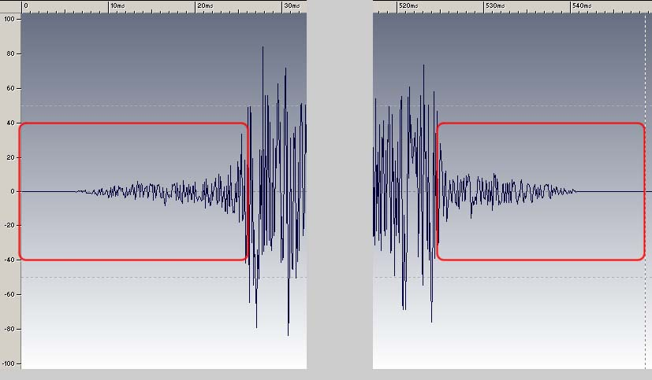

White noise of 1 sec:
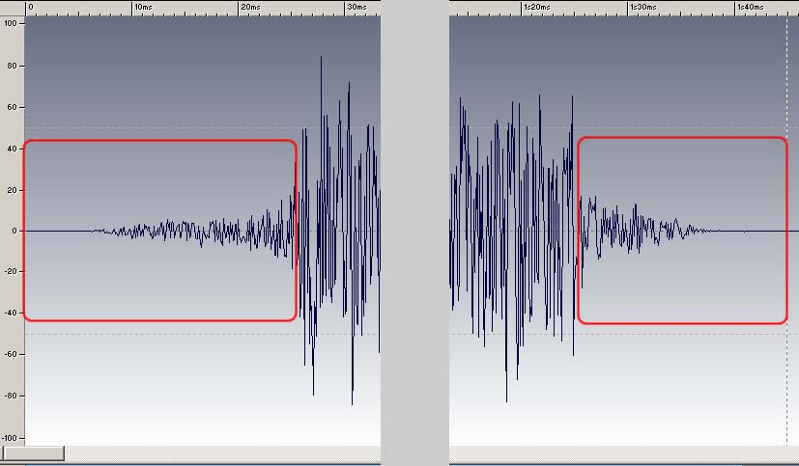

Pink noise of 500 msec:
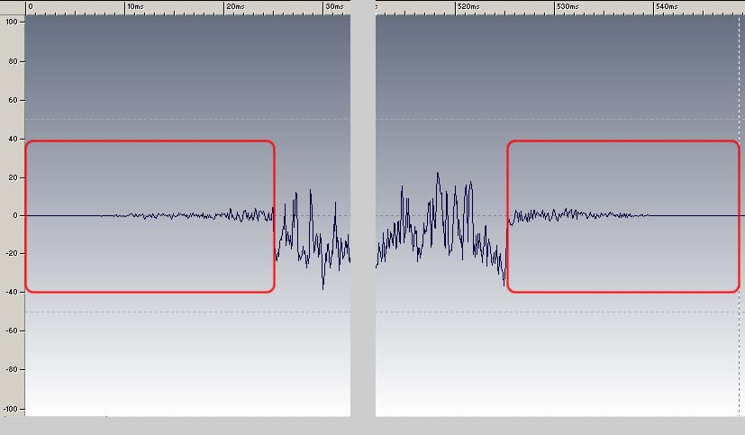

Pink noise of 1 sec:
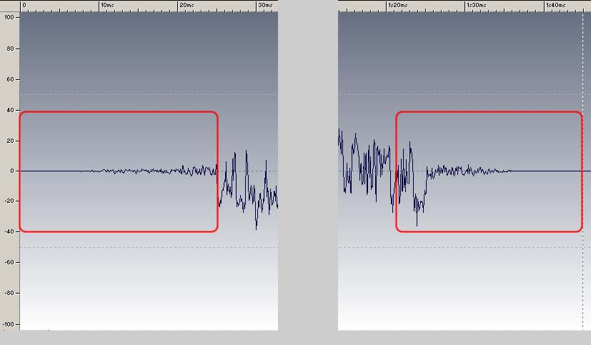

Sinusoidal signal of 500 msec:
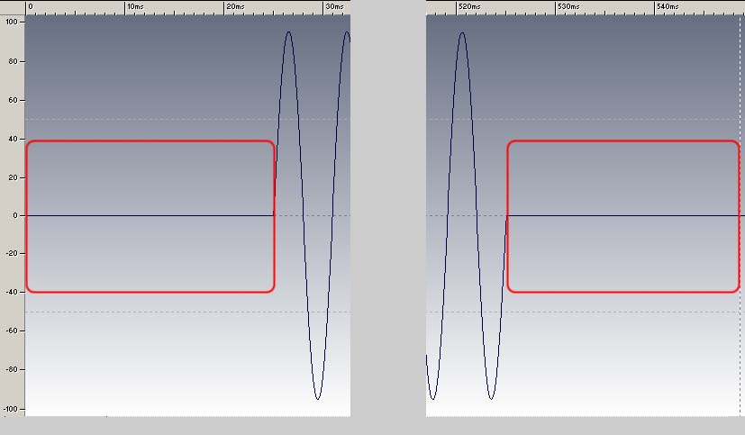

Some music sample of 7 sec 869 msec:
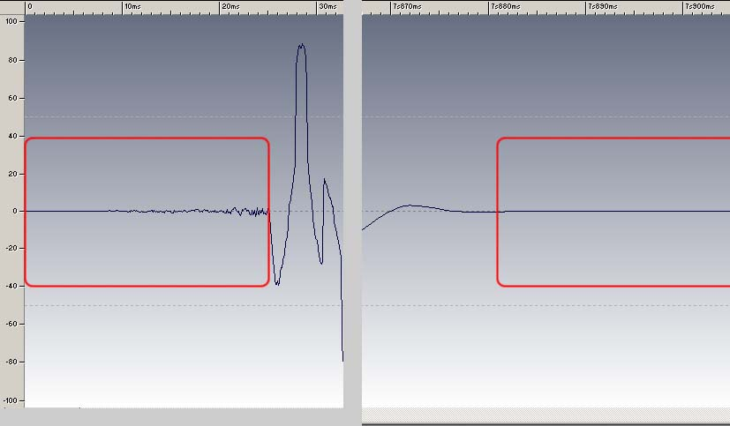

Thus were obtained the following results:
Signal type | The length of sample before encoding | Start delay (msec) | End delay (msec)
White noise | 500 msec | 25 | 24
White noise | 1 sec | 25 | 20
Pink noise | 500 msec | 25 | 23
Pink noise | 1 sec | 25 | 20
Sinusoidal signal | 500 msec | 25 | 23
Some music sample | 7 sec 896 msec | 25 | 33

On start and end the file adds some noise. Also made fade in and fade out the signal at the beginning and end of the file, that the cyclical sample is not good.

As a conclusion we can say:
- When making music cyclical samples can not bother to exact compliance signal levels at the beginning and end of the sample, since mp3 is still a remake at its discretion.
- At the beginning and the end is added to the parasitic signal total length of about 40-60 msec.

This means that our cycle sounded decent, you must get rid of the pause. This can be done, such as the imposition of sound, ie include a new play on the damping of the previous one, or play only the useful signal, by throwing out a delay. Both methods are non-standard loop.
In the first case, at some point of time 2 audio channels on one useful sound. Flash supports only 32 active channels, so in the case of saturated sound scheme, there is a very real chance to get an exception for lack of channels, which could deprive all sound. Since JCAI sound scheme is saturated, so this method is not for us.
Try to realize the second method.
Initial pause simply to remove a standard way, since the method "play" allows you to run a playback from an arbitrary location. In the final pause caused some problems because SoundChannel not generate events of positioning sound playback. Instead, he has a property "position", which determines the position of playback, as well as event "SOUND_COMPLETE", occurred at the end of playback. Thus, one of the easiest options may be a timer. For example, like this:
package
{
import flash.display.Sprite;
import flash.events.Event;
import flash.events.TimerEvent;
import flash.media.Sound;
import flash.media.SoundChannel;
import flash.utils.Timer;

/**
* @author Ezhi, mail:ezhi@story-game-play.com
*/
public class Loop extends Sprite
{
[Embed(source="//..//assets//sample_no_click.mp3")]
private var sampleSrc:Class
private var sampleSound:Sound;
private var soundChannel:SoundChannel;
private var startPadding:Number;
private var endPadding:Number;
private var lengthWantedSignal:Number;
private var loopCount:uint;
private var timer:Timer;

public function Loop():void
{
if (stage) init();
else addEventListener(Event.ADDED_TO_STAGE, init);
}

private function init(e:Event = null):void
{
removeEventListener(Event.ADDED_TO_STAGE, init);

sampleSound = new sampleSrc() as Sound;

startPadding=25;
endPadding=25;
lengthWantedSignal=sampleSound.length-startPadding-endPadding;
loopCount=10;

timer=new Timer(lengthWantedSignal, loopCount);
timer.addEventListener(TimerEvent.TIMER, onTimer);
timer.addEventListener(TimerEvent.TIMER_COMPLETE, onTimerComplete);

soundChannel = sampleSound.play(startPadding);
timer.start();

trace("sample sound length\t"+sampleSound.length);
trace("wanted signal length\t"+lengthWantedSignal);
}

private function onTimerComplete(e:TimerEvent):void
{
trace("loop complete");
timer.removeEventListener(TimerEvent.TIMER, onTimer);
timer.removeEventListener(TimerEvent.TIMER_COMPLETE, onTimerComplete);
}

private function onTimer(e:TimerEvent):void
{

trace("loop: "+timer.currentCount+" sound position\t"+soundChannel.position);
soundChannel.stop();
soundChannel=sampleSound.play(startPadding);
}

}
}

Get the following trace:
sample sound length 548.5714285714286
wanted signal length 498.57142857142856
loop: 1 sound position 548.5714285714286
loop: 2 sound position 350.06802721088434
loop: 3 sound position 396.5079365079365
loop: 4 sound position 396.5079365079365
loop: 5 sound position 350.06802721088434
loop: 6 sound position 548.5714285714286
loop: 7 sound position 396.5079365079365
loop: 8 sound position 350.06802721088434
loop: 9 sound position 396.5079365079365
loop: 10 sound position 350.06802721088434
loop complete

We have an interesting conclusion - the sound and the timer works asynchronously. It means that 1msek timer does not always (or rather, never!) is not equal 1msek playback sound! And we have not a good loop playback. We have "clicking" on mismatch levels and significant pauses, with different sizes. "Clicks" can be removed by increasing the size endPadding to 200. In this case, leaving only "clicks" on the differences between the levels that can be mitigated by selecting a sample more or less uniform sound. However, the creation a timer requires additional resources, and it fact is also necessary considering to implement this option.
Let's try another option. The most regular event stage is ENTER_FRAME. Try to become attached to him. First, let's see how behaves position in relation to this event.
package
{
import flash.display.Sprite;
import flash.events.Event;
import flash.media.Sound;
import flash.media.SoundChannel;

/**
* @author Ezhi, mail:ezhi@story-game-play.com
*/
public class Loop extends Sprite
{
[Embed(source="//..//assets//sample_no_click.mp3")]
private var sampleSrc:Class
private var sampleSound:Sound;
private var soundChannel:SoundChannel;

public function Loop():void
{
if (stage) init();
else addEventListener(Event.ADDED_TO_STAGE, init);
}

private function init(e:Event = null):void
{
removeEventListener(Event.ADDED_TO_STAGE, init);

sampleSound = new sampleSrc() as Sound;

soundChannel = sampleSound.play();

stage.addEventListener(Event.ENTER_FRAME, onEnterFrame);
}

private function onEnterFrame(e:Event):void
{
trace("position\t"+soundChannel.position);
}

}
}

Get the following trace:
position 0
position 0
position 0
position 46.439909297052154
position 139.31972789115645
position 139.31972789115645
position 185.75963718820861
position 232.19954648526075
position 278.6394557823129
position 325.07936507936506
position 371.51927437641723
position 548.5714285714286

From it, we can conclude that our track can be loop only in this points of sample. Lets check how the points are dependent on the mathematical load. Add a function calculating a mathematical value, which will simulate the rendering graphics or physics, and will cause it to function onEnterFrame. For example, this:
private function fakeMath():void
{
for(var i:uint=0; i<10000; i++)
Math.sqrt(Math.pow(Math.sin(Math.random()), Math.cos(Math.random())));
}

Get the following trace:
sample sound length 548.5714285714286
loop positoin 348.57142857142856
position 0
position 46.439909297052154
position 46.439909297052154
position 92.87981859410431
position 92.87981859410431
position 139.31972789115645
position 185.75963718820861
position 232.19954648526075
position 278.6394557823129
position 325.07936507936506
position 371.51927437641723
position 548.5714285714286

The values of the positions have changed slightly. Increase the number of calculations 10 times. Get the following trace:
sample sound length 548.5714285714286
loop positoin 348.57142857142856
position 0
position 92.87981859410431
position 185.75963718820861
position 325.07936507936506
position 548.5714285714286

Values was somewhat less, ie sound is needed the calibration in dependence on the mathematical load. Still, it is calibrated, is quite unambiguous. Therefore, try to get a permanent cycle of sound.
package
{
import flash.display.Sprite;
import flash.events.Event;
import flash.media.Sound;
import flash.media.SoundChannel;

/**
* @author Ezhi, mail:ezhi@story-game-play.com
*/
public class Loop extends Sprite
{
[Embed(source="//..//assets//sample_no_click.mp3")]
private var sampleSrc:Class
private var sampleSound:Sound;
private var soundChannel:SoundChannel;
private var startPadding:Number;
private var endPadding:Number;
private var loopPosition:Number;
private var loopCount:uint;
private var loopNum:uint;

public function Loop():void
{
if (stage) init();
else addEventListener(Event.ADDED_TO_STAGE, init);
}

private function init(e:Event = null):void
{
removeEventListener(Event.ADDED_TO_STAGE, init);

sampleSound = new sampleSrc() as Sound;

startPadding=25;
endPadding=230;
loopPosition=sampleSound.length-endPadding;
loopCount=10;
loopNum=0;

soundChannel = sampleSound.play(startPadding);

stage.addEventListener(Event.ENTER_FRAME, onEnterFrame);

trace("sample sound length\t"+sampleSound.length);
trace("loop position\t"+loopPosition);
}

private function onEnterFrame(e:Event):void
{
fakeMath();

if(loopNum==loopCount)
stage.removeEventListener(Event.ENTER_FRAME, onEnterFrame);
else if(soundChannel.position>=loopPosition && loopNum<loopCount)
{
trace("loop: "+ loopNum+" position\t"+soundChannel.position);
soundChannel.stop();
soundChannel = sampleSound.play(startPadding);
loopNum++;
}
}

private function fakeMath():void
{
for(var i:uint=0; i<10000; i++)
Math.sqrt(Math.pow(Math.sin(Math.random()), Math.cos(Math.random())));
}

}
}

Get the following trace:
sample sound length 548.5714285714286
loop position 318.57142857142856
loop: 1 position 350.06802721088434
loop: 2 position 350.06802721088434
loop: 3 position 350.06802721088434
loop: 4 position 350.06802721088434
loop: 5 position 350.06802721088434
loop: 6 position 350.06802721088434
loop: 7 position 350.06802721088434
loop: 8 position 396.5079365079365
loop: 9 position 350.06802721088434

Obtain reasonable assurance cycle, broken only "clicks". Similarly, checking the version with a timer in this mathematical load, the result is worse.

As result:
Loop sound sample means AC3 may use some portion of fantasy, at least two ways discussed above. In both cases, failed to avoid the sound "clicks" caused by the difference of sound at the junction of the end-beginning. This problem can be almost completely solved the selection of the sound of (an example can be replaced by a sinusoidal signal in the example on sample_1.mp3). Method without the timer showed a more stable and customizable, moreover, it requires fewer resources, which are so expensive.

